**2. System Design**

**2.1 Canvas**

**2.1.1 AEIOU:**

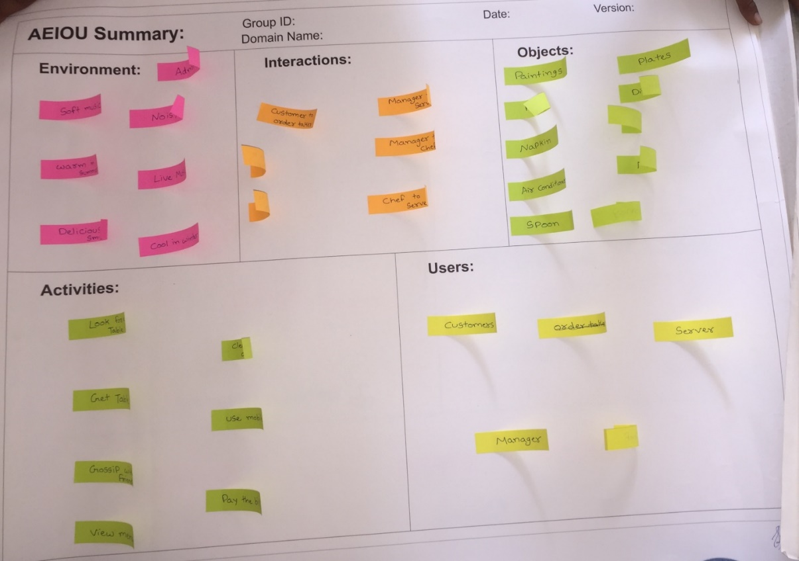

Fig: 2.1.1 AEIOU

AEIOU canvas that describes the Activities, Environment, Interactions,Objects and users of observation site. An Activities shows the overall system actitvities carried out over there that is to set the permissions based on the role,to provide high security and services, user set the imprecision bound and sets the shedule of the diet. Then Environment study includes system,overload,day/night, wheather etc.Interactions includes all the interaction with user like trainner,coach,dietation etc..Objects are weight scale,computer etc.

**2.1.2 EMPATHY Canvas:**

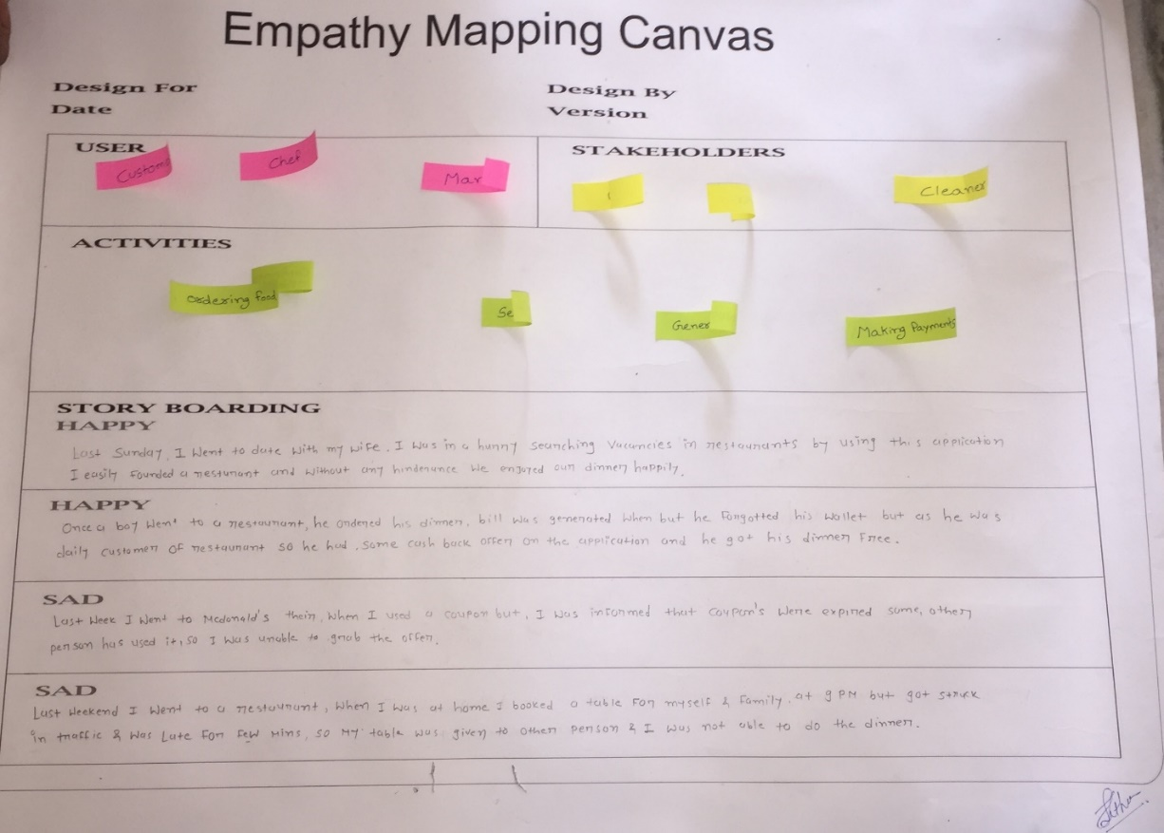

Fig 2.1.2 EMPATHY Canvas

The empathy canvas describes the User that takes the experience of system. Other stakeholders trainners,workers,coach etc. An Activities shows the overall system actitvities carried out over there that is to provide high security and services.

**2.1.3 IDEATION Canvas:**

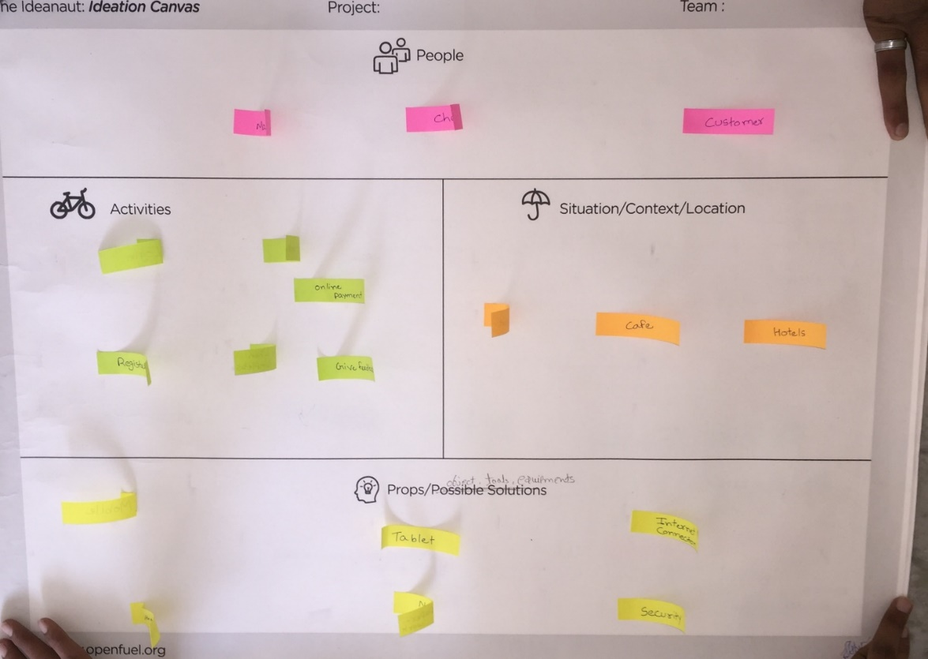

Fig 2.1.3 IDEATION Canvas

Ideation canvas describes the problems and solutions of the system. People include all the peoples involved in system and their activities. Then the situation/context/location describes all the possible location in which the system is used and their possible solutions that purposed to be used by the system.

**2.1.4 PRODUCT DEVELOPMENT Canvas:**

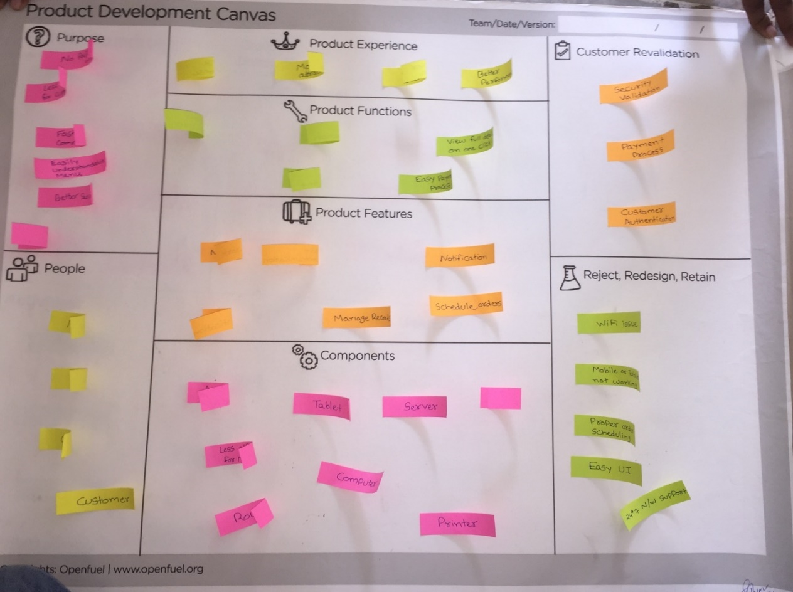

Fig 2.1.4 PRODUCT DEVELOPMENT Canvas

The product development canvas describes the purpose of the system, the experience of the product by end user, functions of product and their features, components that is to be used to develop the system, the peoples involved in the system etc. the problems found by the customer is revalidated and redesigned.

**2.1.5 BMC (Business Model Canvas):**

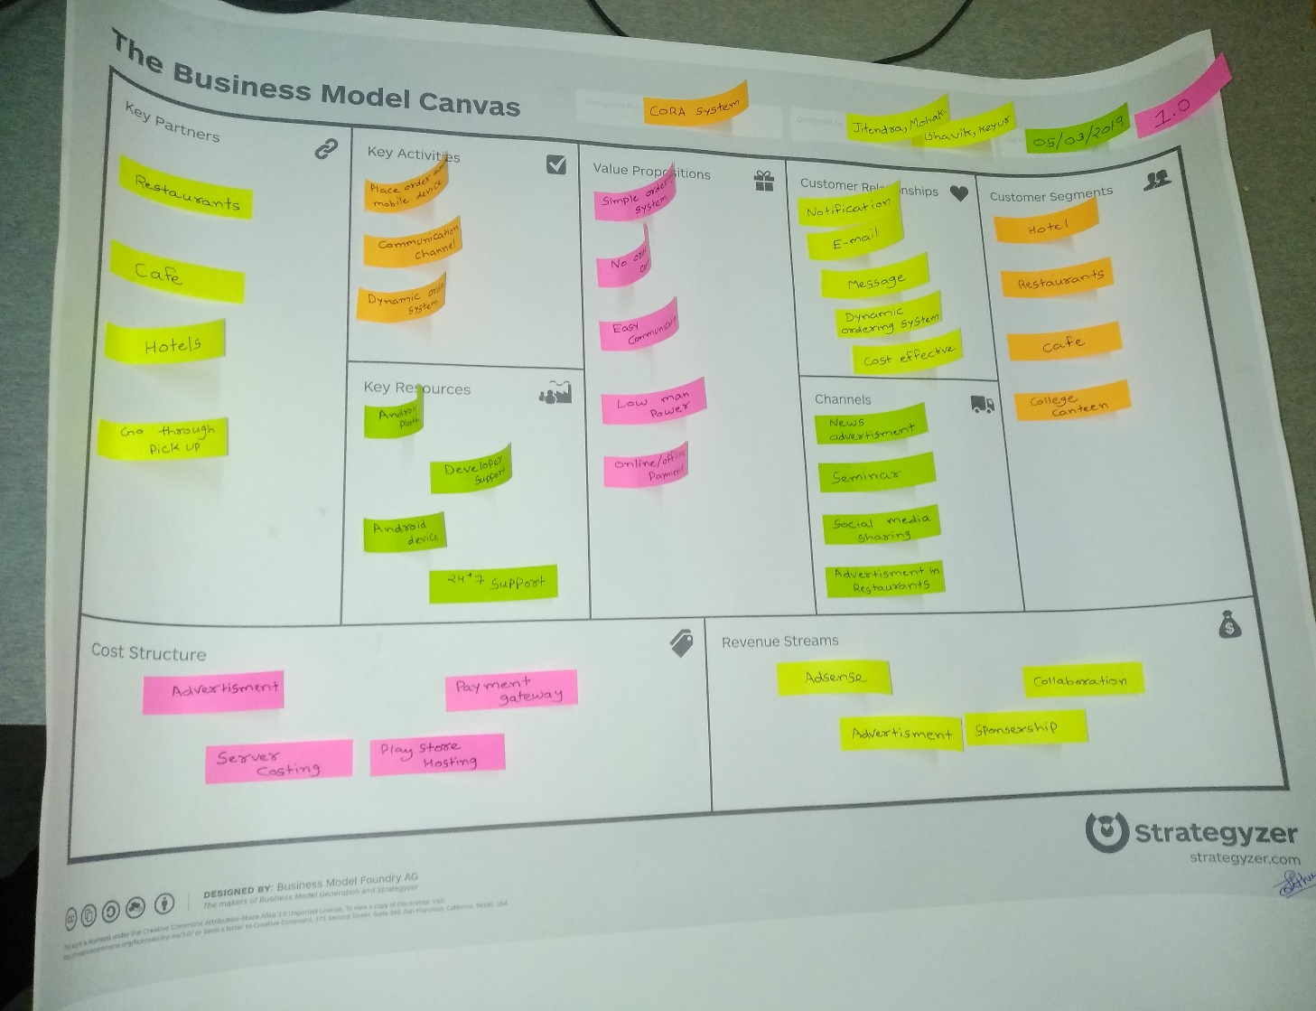

Fig 2.1.5 BMC (Business Model Canvas)

The Business Model Canvas is a visual chart with elements describing a forms or product's value proposition, infrastructure, customers, and finances.

Key Partners is the first form in which the Restaurants, Cafes and Hotels are involved in it.

Value propositions are customers or person who purchase the application.

Customer relationships are up to social media platform and advertising through different medium like newspaper and etc.

Key resources are two types: - 1) **Hardware** = Laptop/Computer, Android Device, Tablet, WIFI and so on. And 2) **Software** = Android SDK, Android Studio and Firebase Database.

The channel denotes how data would be available to end customer so the channel chosen for the system are Application, Social Media and E-mail.

In customer segment includes different Restaurants, Cafes and Hotels.

**2.2 Diagrams**

**2.2.1 Sequence Diagram**

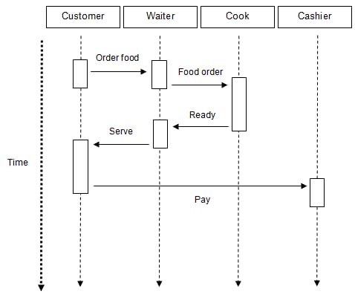

Fig: 2.2.1 sequence diagram

**2.2.2 Activity Diagram**

**Admin:**

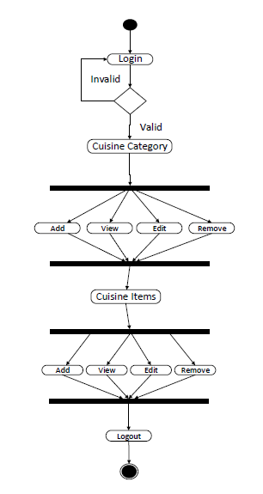

Fig: 2.2.2.1 Activity Diagram Admin

**Customer:**

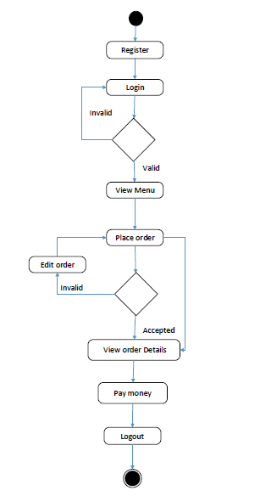

Fig: 2.2.2.2 Activity Diagram Customer

**Cook:**

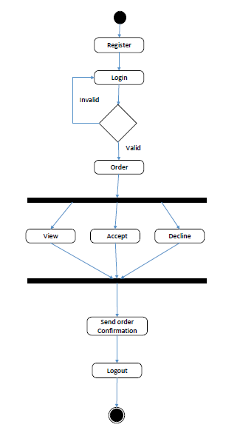

Fig: 2.2.2.3 Activity Diagram Cook

**2.2.3 Use case Diagram**

**Admin:**

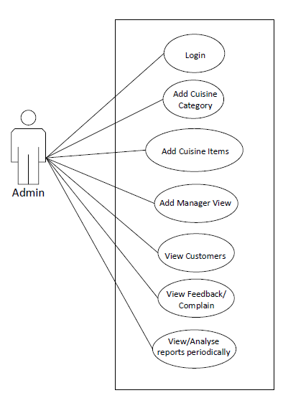

Fig. 2.2.3.1 Use Case Admin

**Customer:**

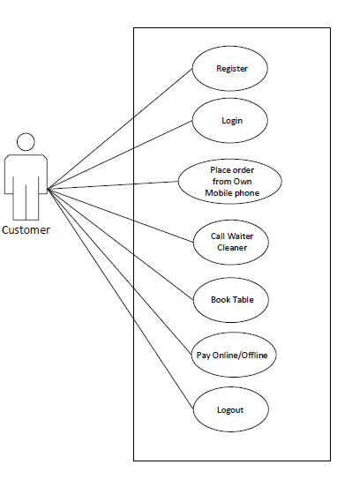

Fig. 2.2.3.2 Use Case Customer

**Cook:**

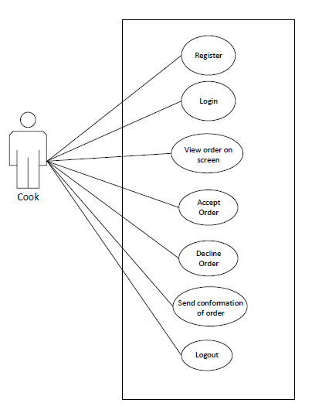

Fig. 2.2.3.3 Use Case Cook

**Manager:**

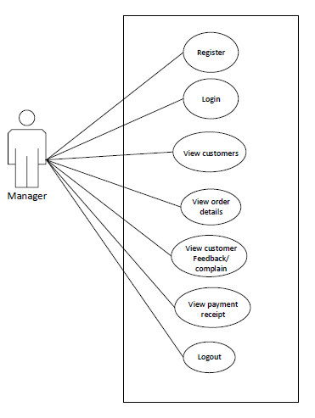

Fig. 2.2.3.4 Use Case Manager

**2.2.4 E-R Diagram**

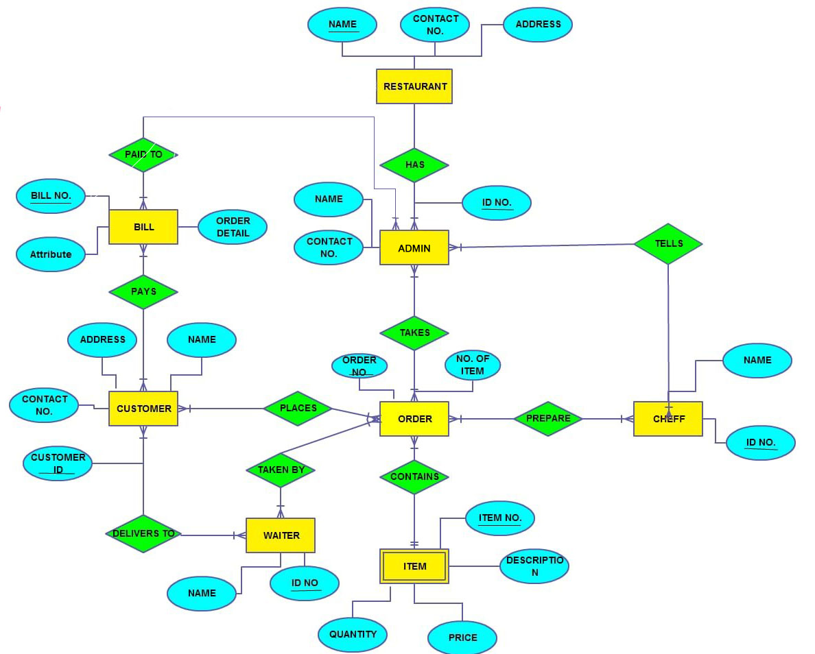

Fig: 2.2.4 E-R Diagram

**2.2.5 Data Flow Diagram**

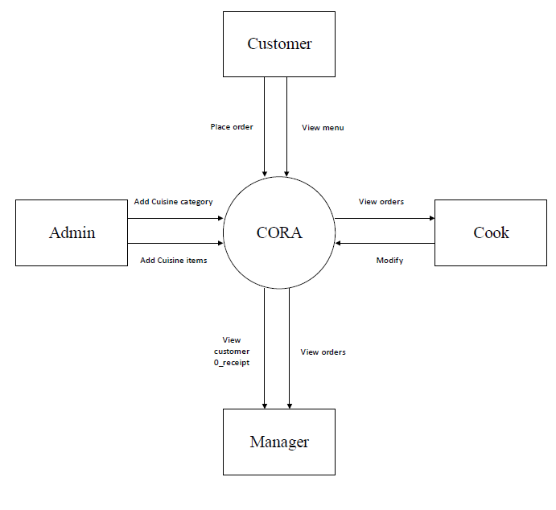

Fig: 2.2.5.1 Data Flow Diagram Level 0

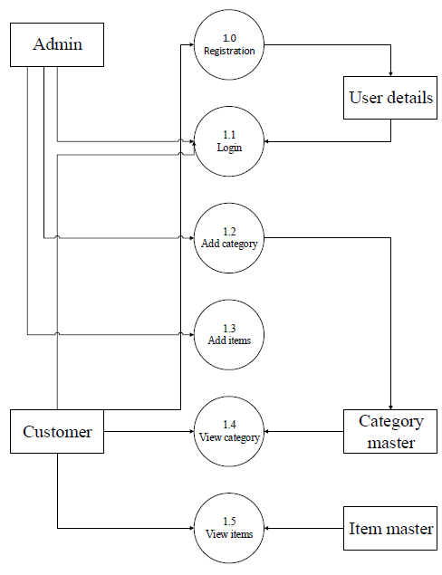

Fig: 2.2.5.2 Data Flow Diagram Level 1

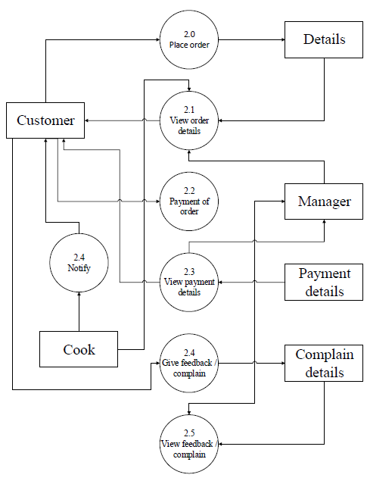

Fig: 2.2.5.3 Data Flow Diagram Level 2

**2.3 Implementation Strategy**

An implementation of all the modules has been completed that includes Login and Registration, Add Category, Add Item, View Item, Ordering, etc.

And at the back-end side full database is created using Firebase. We are using it because its features. Firebase is Real Time Database and growing very well since past some time.